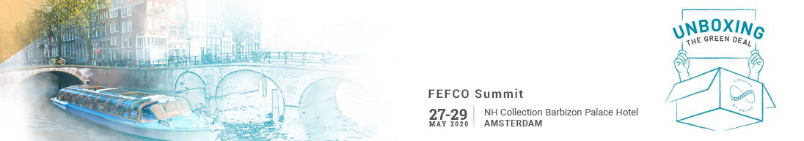

PRESS REGISTRATION FORM

Please complete in typing and return this form to Houriet Lefebvre at houriet.lefebvre@fefco.org

You will receive a badge onsite giving you full access to the FEFCO Summit 2020 in Amsterdam

Newspaper/Magazine/Organisation …………………………………………………………………………………………………………

Title  Mr.  Mrs.  Ms.
First name ……………………………………………. Last name .……………………………………………………….
Function ………………………………………………………………………………………………………………………………….
Address ……………………………………………………………………………………………………….............................................
Postal Code ………………………. City ………………………… Country …………………………………………
Phone …………………………………… Email* ……………………………………….………………………………….
* All communication will be by email.

I would like to display magazines and / or newsletters  Yes  No

Date Signature

