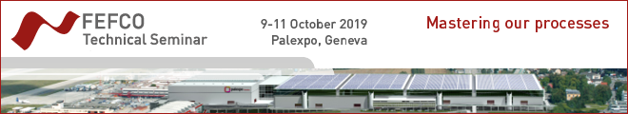

SPONSORSHIP REQUEST FORM

Please complete, date, sign and return this form to Nathalie Schneegans at nschneegans@fefco.org

Sponsorship opportunities are attributed on the basis of first-come, first-served.

Please select your choice and complete the Sponsor billing details below:

- Main Sponsor (1 company) - Not available 13 000 €

A LA CARTE SPONSORSHIP OPPORTUNITIES

- Option A - Signage catering spaces (maximum 4 companies) - Not available 5 000 €
- Option B – large offer of Indoor Signage
(selection to be discussed according to budget and objectives) - Not available
- Option C - WI-FI (1 company) - Not available 4 000 €
- Option D - Lanyards (maximum 2 companies) - Not available 1 500 €
- Option E - Give-away (maximum 2 companies) - Available for one more 2 000 €
- Option F - Seminar e-newsletter (minimum 5 companies) - Available for 4 more 300 €
- Option G - Tailor made sponsorship (to be discussed)

SPONSORSHIP APPLICATION RULES
- The main Sponsor must be an Exhibitor
- The Sponsors are responsible for providing promotional material and for the distribution, display, installation and uninstallation
- The Sponsors are responsible for the production with Palexpo, the Installation and supervision of their banners, displays and or roll-ups.

SPONSOR DETAILS

Name……………………………………………………………………………………………….……………
Gender………………………….………………………………………………………………..………………
Function…...……………………………………………………….………………………………….…………
E-mail…….………………………………………………..Phone/Mobile ……………………………………
Company Name …..……………………………………………………………………………………………
Brand …………………………………………………………….………………………………………………
Activity..………..…………………..…………………………………………………………...........................
Address...…………………………………………….……………………………………………………..……
City ….…………………………………………….Zip code: ………………………………………………….
Country ………………………………………………………………………………………………………….
General E-mail………………………………………………………………..………………………….……..
General Phone: ………………………………………………Website ………………..……………………..
VAT Number…………….………………………………………………………...........................................

Company billing details (if different from the above)
Name ………….……………………………………………………………………………………….……………….
Address ………………………………………………………………….……………………………………..
City ……………………………………………….. Zip code:…………………………………………………
Country………..…………………………………………………………………………………………………
Accountant name ……….……………………………………………………………………………………..
Accountant E-mail……………………………..………………………………………………………………
VAT Number ……………………………………………………………………………………………………
To discuss Sponsorship opportunities, please contact Nathalie Schneegans, FEFCO Communications Director on +32 2 650 08 32 or at nschneegans@fefco.org

Date and place Signature

