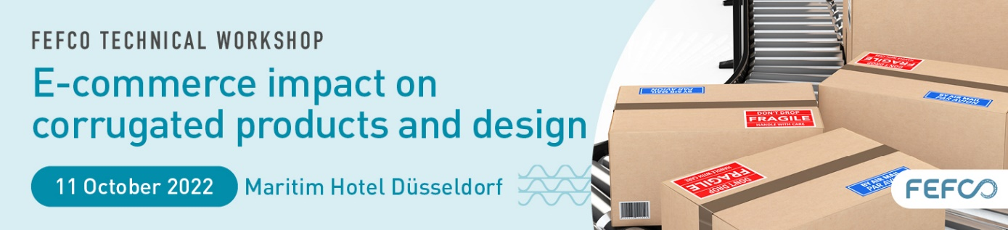

SPONSORSHIP REQUEST FORM

Please complete, date, sign and return this form to Nathalie Schneegans at nathalie.schneegans@fefco.org.

Sponsorship opportunities are attributed first-come, first-served basis.

Please select your choice and complete the Sponsor billing details below:

- Option 1 - Main Sponsor (1 company) Not available 2.500 €

- Option 2 - Give-away (1 company) 750 €

- Taylor-made options - Please contact us at nathalie.schneegans@fefco.org

SPONSORSHIP APPLICATION RULES
- The Sponsors must participate to the event
- The Sponsors are responsible for providing promotional material or text to FEFCO
- Should the main Sponsorship package not be sold; items could be attributed separately upon request, on first come, first served basis.

SPONSOR DETAILS
Name & Surname..………………………………………………………………………….………………
Gender………………………….……………………………………………………………….……………
Function…...……………………………………………………….………………………………….……...
E-mail…….………………………………………………. Phone / Mobile ……….………………………
Company Name …………………………………………………………………………..…………………
Brand …………...…………………………………………….………………………………………………
Activity...………...………………….………………………………………………………….....................
Address...…………………………………………………………………………………….………….……
City ….……………………………………………. Zip code: ……………Country……………………….
General E-mail…………………………………………………………….…………………………...…….
General Phone: ………………………………………………Website ……………...……………..…….
VAT Number………….………………………………………………………...........................................

Company billing details (if different from the above)
Name …….………………………………………………………………………………….………….…….
Address ……………………………………………………………….………………………………..…….
City ….……………………………………………. Zip code: ……………Country...……………………..
Accountant name …….………………………………………………………………………………….….
Accountant E-Mail………………………….…….………………………………………………………….
VAT Number …………………………………………………………………………………………………

Date and place Signature

