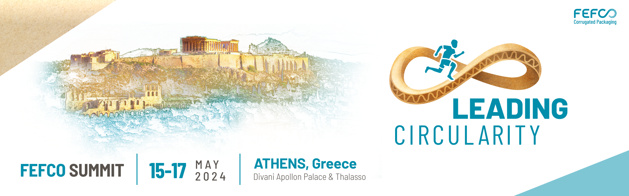

SPONSORSHIP REQUEST FORM

Please tick your choice, complete date, sign and return this form to nschneegans@fefco.org

❑ Gold Sponsor 8.000 €
❑ Silver Sponsor 5.000 €
❑ Bronze Sponsor 4.000 €

A LA CARTE SPONSORSHIP OPPORTUNITIES
- Lanyards for badges  Type of clips to be confirmed  Maximum one company | 2.000,00 €
- Mobile Application for events  Highlight your company name in the Summit Mob App | 300,00€
- Tailor-made Sponsorship  Send your ideas and suggestions to FEFCO | Case by case

APPLICATION RULES
Sponsorships are attributed in order of request receipt, first come, first served.
- The Sponsor must be a member of FEFCO
- The sponsor is responsible for providing, handling and displaying their sponsorship material
- The sponsor is responsible for the supervision of the installation and removal of banners, displays, roll-ups or any other promotional material.

SPONSOR DETAILS

Name. ………………………………………………………………Gender: …………….…………………….…

Function ……………………………………………………………….…………………………………………….

Direct line: ……………………………………E-mail …………………….……………………..………………..

Company Name …………..……………………………………………………………..…………………………

Brand ……………..……………………………………………………………….……………………….………..

Activity …..………………………………………………………………………………….…………………........

Address ....……………………………………………………..………….……………………………………….

City ……………………………………………….. Zip code: ……………………….. Country …….………..
General Phone…………………………………………………….……………………………..…………………

General E-mail: ………………………………………………………Website: …………………..……………..
VAT Number …………………………………….…………………………………………………...……….........

Billing details (if different from above)
Company …………………………………….………………………………………………………...……………
Address ……………………………………………………………………………………………….…….………
City ……………………………………………….. Zip code: ……………………….. Country………………
Accountant E-mail: ……………………………………………………………..………………………………….
VAT Number………………………………………………………………………………………………………...
To discuss further Sponsorship opportunities please contact Nathalie Schneegans, Communications
Director at nschneegans@fefco.org or on +32 473 48 49 08.

Date: Signature:

